Copyright for test papers and marking guides remains with West Australian Test Papers.
Test papers may only be reproduced within the purchasing school according to the advertised Conditions of Sale.
Test papers should be withdrawn after use and stored securely in the school until Wednesday June 22nd 2018.


MATHEMATICS
SPECIALIST
UNIT 1

Semester One

2018

SOLUTIONS

Calculator−free Solutions

1. (a) $b-a=\left(\begin{matrix}1 \\ 3\end{matrix}\right)-\left(\begin{matrix}2 \\ 1\end{matrix}\right)=\left(\begin{matrix}-1 \\ 2\end{matrix}\right)$
$∴a∙\left(b-a\right)=\left(\begin{matrix}2 \\ 1\end{matrix}\right)∙\left(\begin{matrix}-1 \\ 2\end{matrix}\right)=-2+2=0$
$∴a⊥\left(b-a\right)$

(b) (i) $\vec{OC}=\vec{AB}=b-a=-i+2j$

(ii) $\vec{AC}=\vec{OC}-\vec{OA}=-3i+j$
$∴\left|\vec{AC}\right|=\sqrt{10}$
OR
$\left|\vec{AC}\right|=\left|\vec{OB}\right|$
$∴\left|\vec{AC}\right|=\left|\begin{matrix}1 \\ 3\end{matrix}\right|=\sqrt{10}$ [6]

2. (a) (i) $\frac{13!+12!}{13!-12!}=\frac{13×12!+12!}{13×12!-12!}=\frac{12!\left(13+1\right)}{12!\left(13-1\right)}$
$=\frac{14}{12}=\frac{7}{6}$

(ii) $\frac{{{}_{ }^{10}C}_{4}}{{}_{ }^{8}{C_{4}}} =\frac{10!}{4!×6!}÷\frac{8!}{4!×4!}$
$=\frac{10×9×8!×4!×4!}{8!×6×5×4!}=\frac{10}{5}×\frac{9}{6}$ $=2×\frac{3}{2}=3$

(b) LHS $=k\left(\begin{matrix}n \\ k\end{matrix}\right)=k×\frac{n!}{k!\left(n-k\right)!}$
$=\frac{k}{k}×\frac{n!}{\left(k-1\right)!\left[n-k\right]!}$
$=n×\frac{\left(n-1\right)!}{\left(k-1\right)!\left[\left(n-1\right)-(k-1)\right]!}$
$=n\left(\begin{matrix}n-1 \\ k-1\end{matrix}\right)=$ RHS (Or from RHS to LHS) [8]

3. (a) $-3>-5$ but ${\left(-3\right)}^{2}=9>{\left(-5\right)}^{2}=25$ is false

(b) “If the triangle is not equilateral, then the triangle does not
have three equal sides.”
Yes is it always true since the original implication is always
true by definition of equilateral triangles.

(c) “If n is divisible by 3, then n is divisible by 6”.
The converse is not always true, because for n to be
divisible by 6 is must be divisible by both 2 and 3.

(d) FOR ALL natural numbers p, EXISTS a real number q,
such that q is the square root of p. [7]

4. (a) $a+b=\left(\begin{matrix}2 \\ -1\end{matrix}\right)+\left(\begin{matrix}-1 \\ 4\end{matrix}\right)=\left(\begin{matrix}1 \\ 3\end{matrix}\right)$
$∴\hat{\left(a+b\right)}=±\frac{1}{\sqrt{10}}\left(\begin{matrix}1 \\ 3\end{matrix}\right)$
$∴u=2\sqrt{10}×±\frac{1}{\sqrt{10}}\left(\begin{matrix}1 \\ 3\end{matrix}\right)=±\left(\begin{matrix}2 \\ 6\end{matrix}\right)$
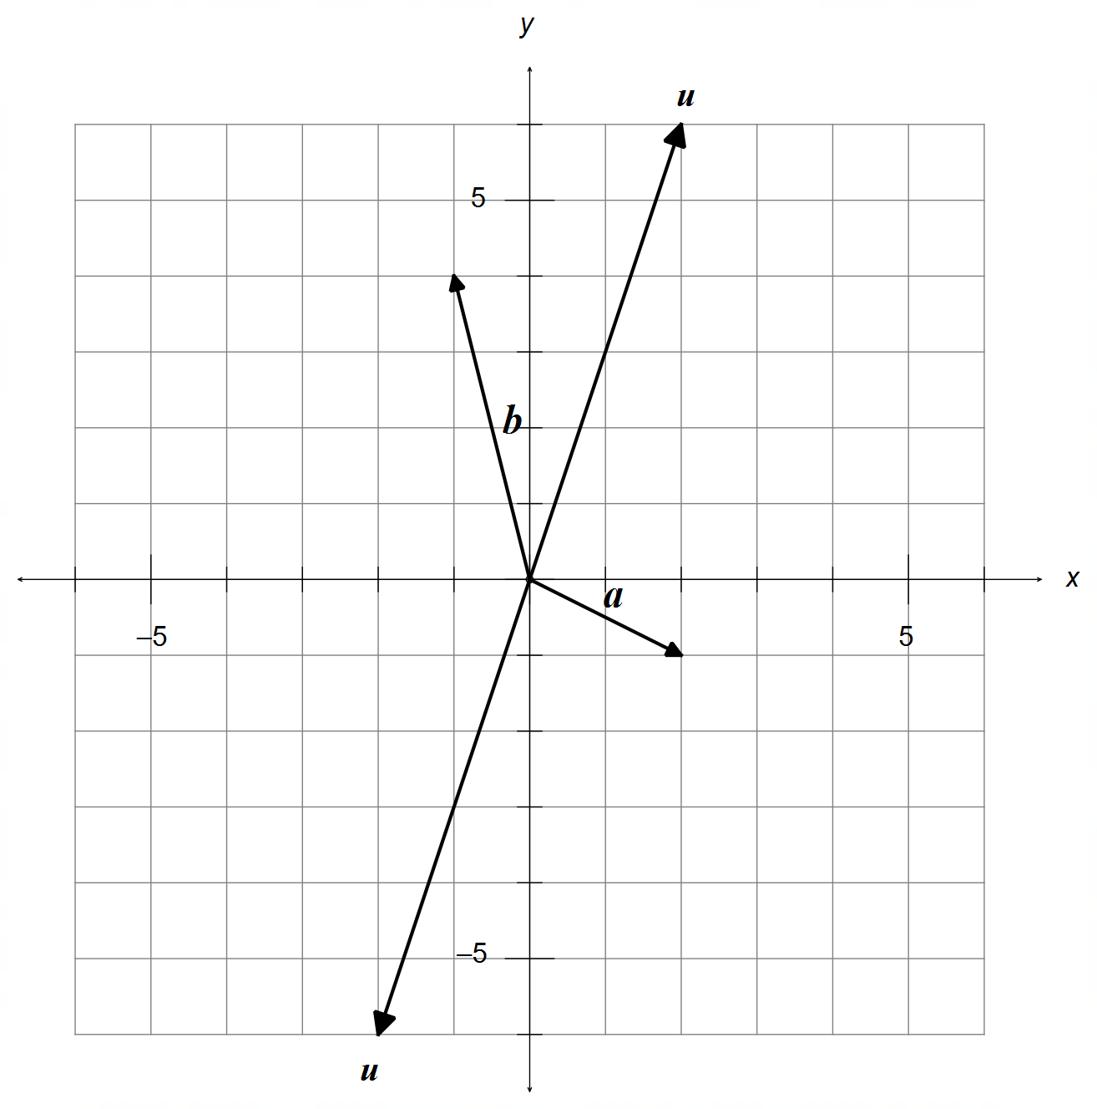

(b) (i) $c=ka$
$\left(\begin{matrix}-4 \\ α\end{matrix}\right)=k\left(\begin{matrix}2 \\ -1\end{matrix}\right) → k=-2 → α=2$

(ii) $\left|\left(\begin{matrix}-4 \\ α\end{matrix}\right)-\left(\begin{matrix}-1 \\ 4\end{matrix}\right)\right|=3\left|\begin{matrix}2 \\ -1\end{matrix}\right|$
$∴\sqrt{9+{\left(α-4\right)}^{2}}=3\sqrt{5}$
$9+{\left(α-4\right)}^{2}=9×5$
${\left(α-4\right)}^{2}=36$
$α=4±6 → α=10 or -2$ [10]
5. (a) $\vec{AC}∙\vec{OB}=\left(c-a\right)∙\left(a+c\right)=0$
$c∙a+c∙c-a∙a-a∙c=0$
${\left|c\right|}^{2}-{\left|a\right|}^{2}=0 → \left|a\right|=\left|c\right|$
$∴$ OABC is a rhombus

(b) LHS $={\left|AC\right|}^{2}+{\left|OB\right|}^{2}={\left|c-a\right|}^{2}+{\left|a+c\right|}^{2}$
$=\left(c-a\right)∙\left(c-a\right)+\left(a+c\right)∙\left(a+c\right)$
$=c∙c-2a∙c+a∙a+a∙a+2a∙c+c∙c$
$=2{\left|a\right|}^{2}+2{\left|c\right|}^{2}$
$={\left|OA\right|}^{2}+{\left|AB\right|}^{2}+{\left|BC\right|}^{2}+{\left|OC\right|}^{2}$ as required [7]

6. (a) ∠AED = 90°
Triangle in a semi-circle is always right angled.

(b) ∠ABE = ∠ADE = 60°
Angles within the same segment are congruent.

(c) ∠CAE = 80°
Opposite angles in a cyclic quadrilateral are supplementary

(d) ∠TCE = ∠CBE = 100°
The alternate segment theorem. [8]

7. $\vec{AB}=\frac{2}{3}\vec{AC}$
$∴b-a=\frac{2}{3}\left(c-a\right)$
$\left(\begin{matrix}1 \\ 3\end{matrix}\right)-\left(\begin{matrix}x \\ -1\end{matrix}\right)=\frac{2}{3}\left(\begin{matrix}4-x \\ y+1\end{matrix}\right)$
$∴x=-5$ and $y=5$ [4]

Calculator−assumed Solutions

8. (a) Assume all non-repeated numbers are selected from
both sets: 3, 8, 4, 6 = 4 digits
Plus all remaining digits from one set: 1, 2, 5, 7 = 4 digits
Plus one more digit to make the first repetition
$∴$ 4 + 4 + 1 = 9 digits minimum

(b) Assume the largest numbers are chosen first:
8 + 7 + 7 + 6 = 28
one more digit could include the number 5, making
the sum over 30.
$∴$ 4 digits max [54

9. (a) (i) ${}_{ }^{22}{C_{8}}=319 770$
(ii) ${}_{ }^{12}{C_{4}}×{}_{ }^{10}{C_{4}}=103 950$
(iii) ${}_{ }^{22}{C_{8}}-{}_{ }^{20}{C_{6}}=281 010$
(iv) ${}_{ }^{2}{C_{2}}×{}_{ }^{20}{C_{6}}+{}_{ }^{2}{C_{0}}×{}_{ }^{20}{C_{8}}=38 760+125 970=164 730$

(b) (i) $8!=40 320$
(ii) $3!×6!=4 320$
(iii) $8!-2!×7!=30 240$ [12]

10. (a) II and III
(b) ${}_{ }^{10}{C_{1}}×{}_{ }^{60}{P_{6}}×{}_{ }^{42}{C_{1}}$ OR ${}_{ }^{10}{C_{1}}×{}_{ }^{60}{C_{6}}×{}_{ }^{42}{C_{1}}×6!$
(c) LHS $=\frac{n!}{r!×\left(n-r\right)!}+\frac{n!}{\left(r+1\right)!×\left(n-r-1\right)!}$
$=\frac{n!}{r!×\left(n-r-1\right)!}×\left[\frac{1}{\left(n-r\right)}+\frac{1}{\left(r+1\right)}\right]$
$=\frac{n!}{r!×\left(n-r-1\right)!}×\left[\frac{r+1+n-r}{\left(n-r\right)\left(r+1\right)}\right]$
$=\frac{n!×\left(n+1\right)}{r!×\left(r+1\right)×\left(n-r-1\right)!×\left(n-r\right)}$
$=\frac{\left(n+1\right)!}{\left(r+1\right)!×\left(n-r\right)!}$
$=\frac{\left(n+1\right)!}{\left(r+1\right)!×\left[\left(n+1\right)-\left(r+1\right)\right]!}$
$={}_{ }^{n+1}{C_{r+1}}=$ RHS [10]

11. (a) (i) $p+q$
(ii) $2p-q$
(iii) $-\left(3p+2q\right)$
(iv) $2q-p$
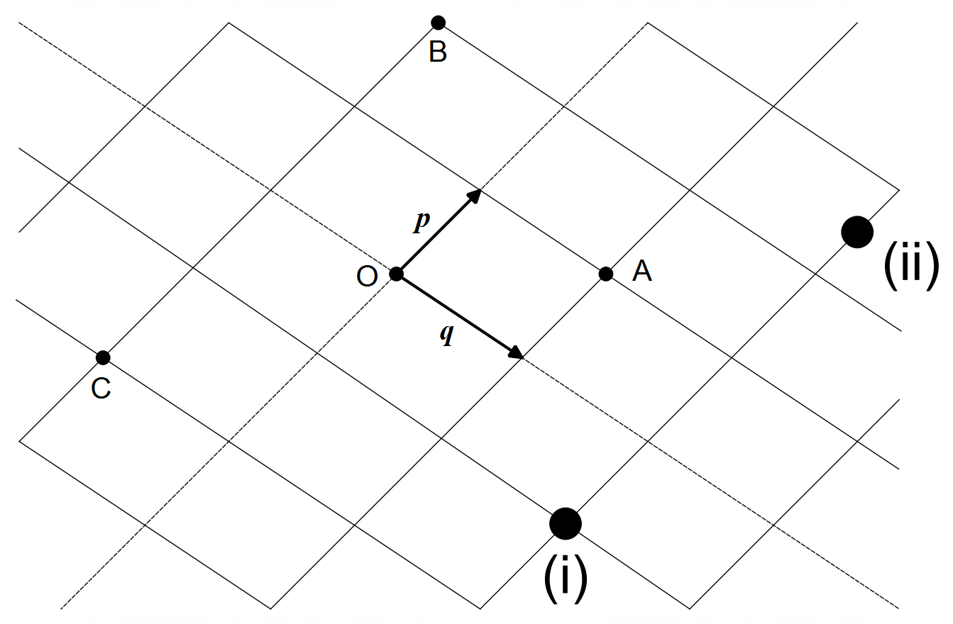 (b)

[6]

12. (a) $\vec{AC}=\left(\begin{matrix}2 \\ k\end{matrix}\right)-\left(\begin{matrix}-2 \\ 0\end{matrix}\right)=\left(\begin{matrix}4 \\ k\end{matrix}\right)=4i+kj$
$\vec{BC}=\left(\begin{matrix}2 \\ k\end{matrix}\right)-\left(\begin{matrix}1 \\ -3\end{matrix}\right)=\left(\begin{matrix}1 \\ k+3\end{matrix}\right)=i+\left(k+3\right)j$
(b) $\left|\begin{matrix}4 \\ k\end{matrix}\right|=\left|\begin{matrix}1 \\ k+3\end{matrix}\right|$
$∴\sqrt{4^{2}+k^{2}}=\sqrt{1^{2}+{\left(k+3\right)}^{2}}$
$∴k=1$
(c) $D=\left(\frac{-2+1}{2},\frac{0-3}{2}\right)=\left(-0.5,-1.5\right)$
(d) $\vec{DC}=\left(\begin{matrix}2 \\ 1\end{matrix}\right)-\left(\begin{matrix}-0.5 \\ -1.5\end{matrix}\right)=\left(\begin{matrix}2.5 \\ 2.5\end{matrix}\right)$
$\vec{DB}=\left(\begin{matrix}1 \\ -3\end{matrix}\right)-\left(\begin{matrix}-0.5 \\ -1.5\end{matrix}\right)=\left(\begin{matrix}1.5 \\ -1.5\end{matrix}\right)$
$∴\vec{DC}∙\vec{DB}=\left(\begin{matrix}2.5 \\ 2.5\end{matrix}\right)∙\left(\begin{matrix}1.5 \\ -1.5\end{matrix}\right)=2.5×1.5-2.5×1.5=0$
$∴\vec{DC}⊥\vec{DB} →$∠CDB is right angled [7]

13. (a) (i) True.
If a number is divisible by 6, then it is also divisible
by both 2 and 3.
(ii) False.
It must be divisible by both 2 and 3.
(iii) True.
The conjunction AND means that it is divisible by both
2 and 3, and therefore it is also divisible by 6.
(b) Assume that $n$ is odd AND that $3n+5$ is also odd
$∴∃ k∈N$ such that $n=2k+1$
$∴3n+5$ $=3\left(2k+1\right)+5$
$=6k+8=2\left(3k+4\right)=$ even
Since $3n+5$ is both odd and even simultaneously, this is
a contradiction, implying that $n$ must be even.
(c) $\vec{OE}+\vec{AD}+\vec{BF}$
$=\left[b+\frac{1}{2}\left(a-b\right)\right]+\left[-a+\frac{1}{2}b\right]+\left[-b+\frac{1}{2}a\right]$
$=\left(\frac{1}{2}a-a+\frac{1}{2}a\right)+\left(b-\frac{1}{2}b-\frac{1}{2}b\right)=0$ [15]

14. (a) $F_{1}\cos{30°}=F_{2}\cos{45°}$
$∴\frac{\sqrt{3}}{2}F_{1}=\frac{1}{\sqrt{2}}F_{2}$
$F_{1}\sin{30°}+F_{2}\sin{45°}=250$
$∴\frac{1}{2}F_{1}+\frac{1}{\sqrt{2}}F_{2}=250$
(b) $F_{2}=\frac{\sqrt{6}}{2}F_{1}$
$∴\frac{1}{2}F_{1}+\frac{\sqrt{3}}{2}F_{1}=250$
$∴F_{1}=\frac{500}{1+\sqrt{3}}=183.01N$
$∴F_{2}=\frac{\sqrt{6}}{2}×\frac{500}{1+\sqrt{3}}=\frac{250\sqrt{6}}{1+\sqrt{3}}=224.14N$
(c) If $F_{1}=200N$ then $F_{2}=\frac{\sqrt{6}}{2}×200=244.95N>200N$
$∴$ Cable 2 exceeds its maximum load, hence Cable 1
must not reach its 200N maximum rating
If $F_{2}=200N$ then $F_{1}=\frac{2}{\sqrt{6}}×200=163.30N<200N$
Max Force $=F_{1}\sin{30°}+F_{2}\sin{45°}$
$=\frac{400}{\sqrt{6}}×\frac{1}{2}+200×\frac{1}{\sqrt{2}}=223.07N$ [12]

15. (a) $n\left(D∪C\right)=n\left(D\right)+n\left(C\right)-n(D∩C)$
$810=400+500-n(D∩C)$
$∴n\left(D∩C\right)=90$
(b) $n\left(D∪C∪B\right)=n\left(D\right)+n\left(C\right)+n\left(B\right)$
$-n\left(D∩C\right)-n\left(D∩B\right)-n(C∩B)$
$+n(D∩C∩B)$
$900=400+500+210-90-60-110+n\left(D∩C∩B\right)$
$∴n\left(D∩C∩B\right)=50$ [6]

16. (a) ${\left({}_{ }^{3}{C_{1}}\right)}^{2}={}_{ }^{3}{C_{2}}+{}_{ }^{4}{C_{2}}$
${\left({}_{ }^{5}{C_{1}}\right)}^{2}={}_{ }^{5}{C_{2}}+{}_{ }^{6}{C_{2}}$
(b) $a=2$
$b=n+1$
(c) ${\left({}_{ }^{6}{C_{1}}\right)}^{2}={}_{ }^{8}{C_{3}}-{}_{ }^{6}{C_{3}}$
(d) ${\left({}_{ }^{n}{C_{1}}\right)}^{2}={}_{ }^{n+2}{C_{3}}-{}_{ }^{n}{C_{3}}$ [8]

17. (a) $\vec{OE}=a+\frac{1}{2}\left(b-a\right)=\frac{1}{2}\left(a+b\right)$
$\vec{OF}=c+\frac{1}{2}\left(b-c\right)=\frac{1}{2}\left(b+c\right)$
(b) $\vec{DE}=\vec{OE}-\vec{OD}=\frac{1}{2}\left(a+b\right)-\frac{1}{2}a=\frac{1}{2}b$
$\vec{GF}=\vec{OF}-\vec{OG}=\frac{1}{2}\left(b+c\right)-\frac{1}{2}c=\frac{1}{2}b=\vec{DE}$
$\vec{DG}=\vec{OG}-\vec{OD}=\frac{1}{2}c-\frac{1}{2}a=\frac{1}{2}\left(c-a\right)$
$\vec{EF}=\vec{OF}-\vec{OE}=\frac{1}{2}\left(b+c\right)-\frac{1}{2}\left(a+b\right)=\frac{1}{2}\left(c-a\right)=\vec{DG}$
$∴\vec{DE}=\vec{GF} and \vec{DG}=\vec{EF} ⇒$DEFG is a parallelogram [7]

18. $BF×FD=CF×FA$
$∴x\left(2y\right)=2x\left(6\right) → y=6 cm$

$MD×MB=MT^{2}$
$∴4×\left(4+12+x\right)={\sqrt{76}}^{2} → x=3 cm$

$NT^{2}=NC×\left(NC+FC+FA\right)$
$∴z^{2}=6×\left(6+6+6\right) → z=6\sqrt{3} cm$ [6]

19. Let $\hat{n}$ be a unit vector perpendicular to $b$
then, $a=u+\left|u\right|\tan{60°}\hat{n}$
$\left|u\right|=\left|\begin{matrix}3 \\ 1.5\end{matrix}\right|=\frac{3}{2}\sqrt{5}$
$n∙\left(\begin{matrix}4 \\ 2\end{matrix}\right)=0 →$ let $n=±\left(\begin{matrix}-1 \\ 2\end{matrix}\right)$
$∴\hat{n}=±\frac{1}{\sqrt{5}}\left(\begin{matrix}-1 \\ 2\end{matrix}\right)$
$∴a=\left(\begin{matrix}3 \\ 1.5\end{matrix}\right)+\frac{3}{2}\sqrt{5}×\sqrt{3}×±\frac{1}{\sqrt{5}}\left(\begin{matrix}-1 \\ 2\end{matrix}\right)=\left(\begin{matrix}3 \\ 1.5\end{matrix}\right)±\frac{3}{2}\sqrt{3}\left(\begin{matrix}-1 \\ 2\end{matrix}\right)$
$∴x=3±\frac{3}{2}\sqrt{3}$ and $y=\frac{3}{2}∓3\sqrt{3}$ [6]

